|  |
| --- |
| **VISHVASREE V** |
| **4AL16EC087** |
| **8th sem B sec** |

**Report of Day 1**

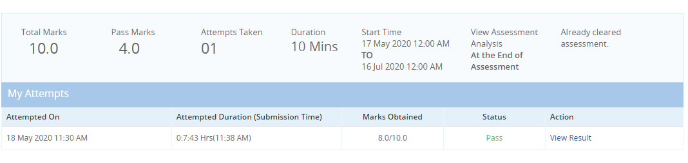

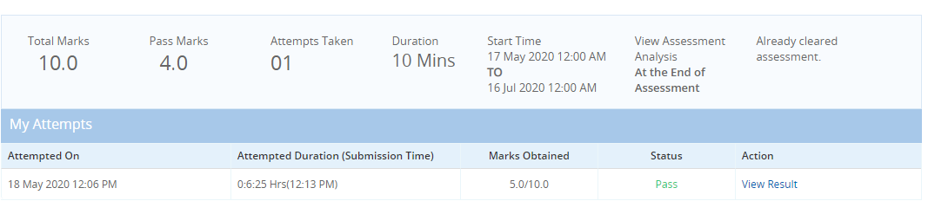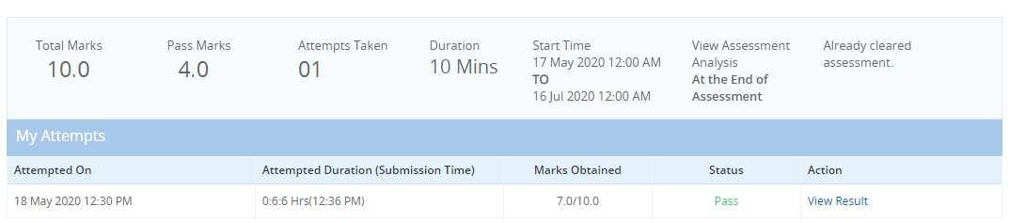

**Communicate to impress**

* Importance of communication, process of communication, barriers of communication, verbal and nonverbal communication.
* Communication can be verbal, nonverbal, visual, written
* Barriers to communication
* Retention capability
* Inattentiveness
* Status
* Closed mind
* Source of communication
* Nonverbal communication
* facial expression
* paralanguage
* gestures
* Posture
* Eye content
* Appearance
* Effective communication: Does
* Maintain eye contact
* Dress for occasion
* Speak with clarity
* Correct posture
* Positive Gestures
* Effective communication: Dont’s
  + Checking your phone while conversing
  + Dressing shabbily

**Deliver presentation with impact**

* Design effective PPTs, Make an effective presentation, Dos and don’ts in presentation skills
* 5W’s
  + What
  + Who
  + Why
  + Where
  + When
* A few image per slides
* One thought per slide
* Effective use of quotations
* Readable fonts
* Avoid upper cases
* Attractive slides
* Use images to simplify content
* Background to be simple
* Use visual aids
* Formally dressed
* Knowledge transfer
* Team meeting
* Brain storming

**Develop soft skills for the workplace**

* Importance of soft skills, Distinguish hard and soft skills
* Lack of soft skills
* Need for soft skills
* Recognizing the need for soft skills
* Importance of soft skills
* Difference between soft and hard skill